|  |  |
| --- | --- |
| **World Meteorological Organization**  **JOINT WMO/IOC TECHNICAL COMMISSION FOR OCEANOGRAPHY AND MARINE METEOROLOGY (JCOMM)**  **EXPERT TEAM ON SEA ICE (ETSI)**  **Seventh Session**  Geneva, 13 May to 15 May 2019 | **Intergovernmental Oceanographic Commission (of UNESCO)**  **ETSI-7/Doc. X.X**  Submitted by: ___________, ETSI  9.V.2019  **DRAFT** |

**TITLE**

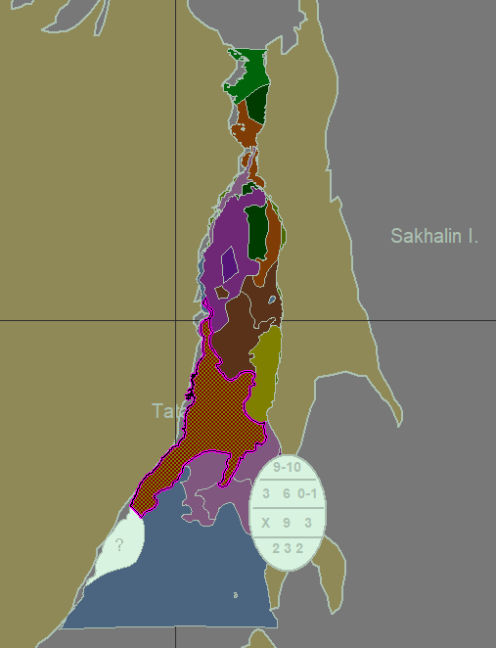

Paragraph text

_____________