Third Ice Analysts Workshop
14-18 June 2011
Danish Meteorological Institute, Copenhagen, Denmark

ANNOUNCEMENT

Background

The provision of marine meteorological and oceanographic services, including sea ice, to meet the requirements of marine users continues to be a high priority for the Joint WMO/IOC Technical Commission for Oceanography and Marine Meteorology (JCOMM), since they contribute substantially to national economies, as well as being essential for the safety of life at sea, as recognized by the SOLAS Convention. Recognizing the increased use of the Polar Regions by all elements of the marine community including commercial, military and scientific research, gaps and problems with availability, harmonization and standardization of appropriate Maritime Safety Information (MSI) (including sea ice) within the new Arctic METAREAs XVII-XXI must be addressed.

To enhance the capability of Members to provide harmonized sea ice services and as a follow-up of the First and Second Ice Analysts Workshops (Rostock, Germany, June 2008, WMO Td. No. 1441, and Tromsö, Norway, June 2009, WMO Td. No. 1517), the JCOMM Expert Team on Sea Ice (ETSI) at its fourth session (St. Petersburg, Russian Federation, March 2010), and the International Ice Chart Working Group (IICWG) at its eleventh session (Washington DC, USA, October 2010), proposed to convene a Third Ice Analysts Workshop. The JCOMM Services and Forecast Systems Programme Area Coordination Group endorsed the Workshop at its fifth session (Melbourne, Australia, May 2010) and confirmed its inclusion in the JCOMM intersessional plan for 2010-2012. At the invitation of the Danish Meteorological Institute (DMI), the Third Ice Analysts Workshop (IAW-3) will take place in Copenhagen, Denmark, from 14 to 18 June 2011.

The IAW-3 will be aimed at improving interoperability between the national ice services and development of reconciled operational ice analysis products, the latter including a series of products and bulletins to ensure marine safety and efficiency of ice navigation in the newly operative Arctic METAREAS XVII-XXI, in the Baltic Sea and in Antarctic waters. The major outcome from this workshop will be the development of guidelines for the reconciliation of the sea-ice services, including coding and presentation schemes for ice charts and imagery.

Objectives of the Workshop

The primary objective of IAW-3 remains the assessment and minimization of differences between current practices of ice analysis and charting at the national ice services to meet operational needs. To help achieve this goal, the workshop encompasses:

- Case studies, presentations and discussions from Ice Services on the techniques used in analyzing imagery and preparing ice charts in order to exchange views and techniques and learn diverse “philosophies” and practices of sea-ice analysis from different Ice Services; and,
- Breakout groups of experts by region (Arctic West/East; Baltic Sea and Antarctic) to analyze imagery and prepare ice charts during the workshop in order to develop a methodology to harmonize the analysis process.
The presentation of case studies, breakout, and plenary sessions will be coordinated by the ETSI chairperson, the host ice service, chairpersons of the breakout groups (to be appointed) and the WMO Secretariat. Deadline for submission of documentation, case studies, ice charts, and imagery is 31 May 2011. DMI will provide access to an ftp server for downloading and uploading all required information.

Logistics

The Workshop will be conducted in English only. A JCOMM Technical Report will be produced, to include all case studies and documentation, as well as recommendations to harmonize sea ice analysis practices and products, including the exchange of ice charting products, coding and presentation schemes.

Updated information regarding the workshop, including case studies, ice charts and imagery, will be available from the JCOMM web site at http://www.jcomm.info/ with a copy of material posted at http://wdc.aari.ru/wmo/iaw3. You are encouraged to visit the web sites regularly for further information concerning the workshop.

Organizing Committee

Dr Vasily Smolyanitsky, Chairperson of the JCOMM Expert Team on Sea Ice (ETSI), Arctic and Antarctic Research Institute (AARI), Russian Federation
Mr Keld Quistgaard (local host representative), Ice Service, Danish Meteorological Institute, Copenhagen, Denmark
Mr Nick Hughes, Norwegian Meteorological Institute, Tromsö, Norway
Dr Jürgen Holfort, Bundesamt fur Seechifffahrt und Hydrographie (BSH), Germany
Ms Darlene Langlois, Canadian Ice Service, Environment Canada, Canada
Mr John Falkingham, (secretariat support), WMO

WORLD METEOROLOGICAL ORGANIZATION  ________________________ | INTERGOVERNMENTAL OCEANOGRAPHIC  COMMISSION (OF UNESCO)  ________________________
JOINT WMO/IOC TECHNICAL COMMISSION FOR  OCEANOGRAPHY AND MARINE METEOROLOGY (JCOMM)  THIRD ICE ANALYSTS WORKSHOP  COPENHAGEN, DENMARK  14 TO 18 JUNE 2011 | IAW-3 DOC 1.0  __________  ITEM 1.0  Original: ENGLISH

PROVISIONAL AGENDA

- Opening of the workshop
  - Opening and welcome
  - Adoption of the agenda
  - Workshop logistics and arrangements

- Reports
  - Key facts of national ice information systems for the last season 2010/2011” (template to be provided by Organizing Committee) (10-15 minutes each).
  - Reports/presentations from JCOMM, Secretariat, ice groups and data providers

- Case studies
  - Workshop logistics
    - Presentation of online resources to be used during case-studies
    - Identification of a strategy for comparing practices and ice products
    - Identification of 3-4 break-out groups:
      - West Arctic (Barents/Greenland Seas) / Antarctic / Baltic
  - Case study #1 (Day 1, Tuesday): “Online analysis of routine dataset and ice charting for a test region by 3-4 teams of ice analysts” (break-out)
  - Case study #2 (Day 2, Wednesday): “Assimilation of ice charts in SIGRID-3 format: interoperability of format implementation across the services, reconciliation of ice edge and adjacent polygons” (plenary)
  - Case study #3 (Day 3, Thursday): “Online composition of sea ice Marine Safety Information (MSI) for GMDSS and NAVTEX bulletins” (plenary)

- Plenary discussions
  - Discussion #1 (Day 2, Wednesday): "Investigating philosophies for ice analysis and requirements from individual clients”
  - Discussion #2 (Day 3, Thursday): “Interoperability of ice charts: SIGRID-3 format implementation across the services, reconciliation of ice edge and adjacent polygons and possible implications on content of Arctic SafetyNET and NAVTEX bulletins"
  - Discussion #3 (Day 4, Friday): "Exchange of practices for satellite imagery relay: georeference and annotation standards, validity times, means for provision to customers, imagery display”.

- Review of existing sea ice regulatory publications (day 5, Saturday)

- Workshop proceedings
  - Development of a summary of operational ice analysis differences and ice charts interoperability
  - Development of guidelines for harmonization of ice practices, delivery of the products and training in ice analysis including preparation of MSI
  - Workshop actions and report

- Close of the workshop

_____________

Third Ice Analysts Workshop

14-18 June 2011
Danish Meteorological Institute, Copenhagen, Denmark

REGISTRATION FORM

Family name: __________________________________________________________________

First name: __________________________________________________________________

Position: __________________________________________________________________

Institution: __________________________________________________________________

Address: __________________________________________________________________

______________________________________________________________________________

Country: __________________________________________________________________

Phone: __________________________________________________________________

FAX: __________________________________________________________________

E-mail: __________________________________________________________________

Please indicate if you are submitting for discussion a case study on the techniques used in analysis imagery and preparing ice charts:

Yes: No:

If yes, please provide detailed information on your submission (e.g., region covered, season, type of imagery, ice charts, etc.):

______________________________________________________________________________

______________________________________________________________________________

Audiovisual and computer requirements: A laptop computer running MS Windows/PowerPoint, multimedia projector, overhead projector, and WiFi, will be available. If you have any other audio-visual and computer requirements, please note these below:
______________________________________________________________________________

Please submit this form by e-mail to Lisbeth Palle, DMI, +45 39 15 72 20, lap@dmi.dk, as soon as possible, but no later than 20 May 2011.

Information for Participants
Meeting Venue
Danish Meteorological Institute
Lyngbyvej 100
2100 Copenhagen
Telephone 39 15 75 00
Fax 39 27 10 80

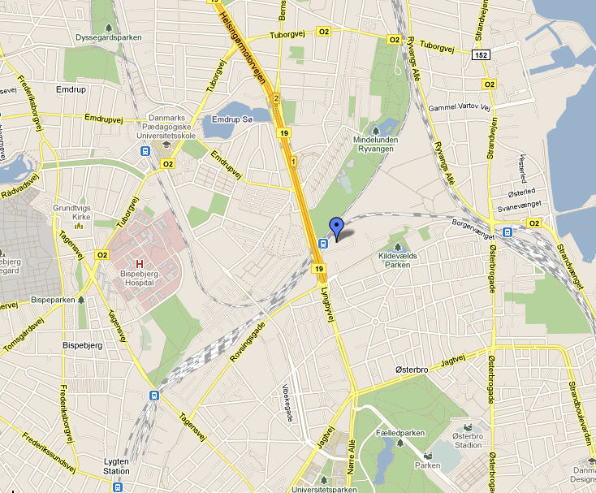

Hotels
Single rooms have been pre-booked at 3 hotels. You need to book your room yourself, and you
must inform of the booking number, which Lisbeth Palle, DMI, +45 39 15 72 20, lap@dmi.dk, will
give you, when you register for the Workshop with Lisbeth. Please beware of the dead-lines for
booking under each hotel.

Hotel Imperial - Vester Farimagsgade 9, 1606 København V, phone +45 33 12 80 00. Price incl.
breakfast DDK 1318,00. Hotel Imperial is a 4 star hotel situated close to the central part of
Copenhagen and next to the S-railway station ”Vesterport”, where you can catch the S-train
directly to ”Ryparken”. Travel time 15 minutes. Choose route ”A” and the direction ”Farum”.
Booking before May 30.

Hotel Astoria - Banegårdspladsen 4, 1570 København V, phone + 45 33 42 99 00.
Price incl. breakfast DDK 895,00. Hotel Astoria is renovated in 2007. It is a 3 star hotel situated
right in the central part of Copenhagen and next to the Central Train Station, where you can catch
the S-train directly to ”Ryparken”. Travel time 19 minutes. Choose route ”A” and the direction
”Farum”. Booking before May 13.

Hotel Centrum – Helgolandsgade 14, 1653 København V, phone + 45 33 31 31 11.
Price incl. breakfast DDK 895,00. It is a 3 star hotel situated right in the central part of Copenhagen
with 5 minutes walk to the Central Train Station, where you can catch the S-train to ”Ryparken”.
Booking before May 13.

