Info for IAW-2 participants

Hotel reservation:
At Hotel City Living in Tromso (http://www.cityliving.no/?did=9072387) , a block reservation is done from June 14 to June 19. Reservations should be made via met.no in Tromso, at the e-mail address: grete.kramer@met.no
If someone wants to stay the weekend after the workshop, the accommodation has to be done individually, as the hotels are very full and do not accept block reservations.
The rooms at City Living Hotel are 3 categories:
Singel roo: NOK 990 pr night
Double room: NOK 1190 pr night
Mini-suite: NOK 1390 pr night
All rooms have ensuite bathroom/shower, and also a kitchenette in each room.

Info on the workshop venue etc
The workshop will be at the met.no office in Tromso; address is Kirkegardsvegen 60, (but it is well known in the city as “Meteorologisk institutt” or “Vervarslinga for Nord-Norge” or “the building at the top of the island with a big polar bear in a glass cage outside”)
Lunch will be provided at the meeting. From the city center (Where Hotel City Living is) there is a 12-15 minutes walk uphill to met.no office. There are also several buses stopping close to the office. Taxi ride from hotel to met.no office is approx. NOK 75.

You will have a variety of good restaurants in the hotel’s neighbourhood. Tromso is well known for a lively nightlife, so there are several possibilities for those who like to hang out. Be aware of the prices!!
We will provide more info to the participants closer to the workshop.

Transportation from airport is easiest by taxi; approx 5 km, cost ca NOK100. The shuttle bus to downtown is also a possibility, but not so frequent service. Cost NOK 50.
The Hotel City Living has no restaurant; but across the street at restaurant “Egon”, breakfast is available for NOK 72 for City Living hotel guests. All rooms at City Living have a kitchenette (meaning you can arrange your own breakfast).
http://www.destinasjontromso.no/english/index.html
http://en.wikipedia.org/wiki/Troms%C3%B8

A zoomable map for Tromsoe is found at:
http://www.norgeskartet.no/norgeskartet/mapAddress.c?ps=2&imgt2=MAP&lne=&q=Kirkeg%E5rdsvegen+60+Troms%F8&imgt=MAP&lnw=&startId=a_2039002&stopId=a_1140924&n=69.6529713781748&s=69.6491590318252&e=18.95405071423&w=18.9368408547473&zoom=2&tool=zoom&scrollX=0&scrollY=0
See also map next page.

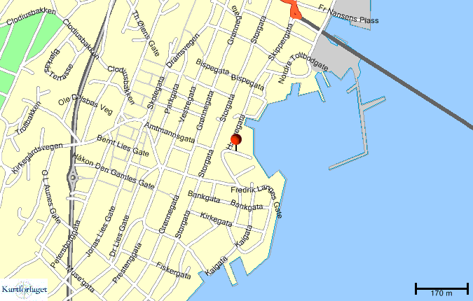
City Living Hotel
Meeting Venue

