Exercise 1 - Preparing Routine Analysis in Southern Hemisphere

*Penelope Wagner ,2016-05-17*

**Background**

Traffic around the Antarctic Peninsula is increasing, predominantly by expedition cruise vessels. Currently this area has ice charts from Norway (Mondays, October to April) and USA/Russia (Thursdays, all year).

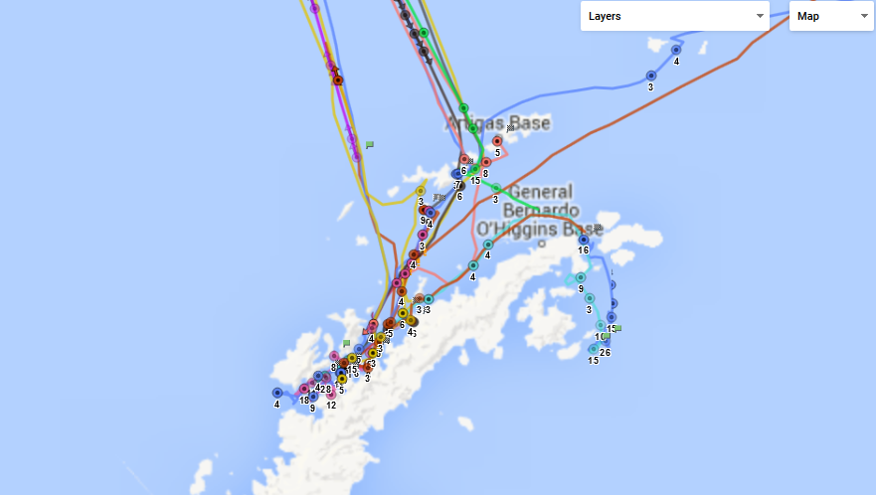  
**Ship traffic around Antarctic Peninsula, 12 December 2015**

Goal

***Participants will divide into two groups to ‘practice’ using the USNIC’s SIPAS [OPS floor] and Norway’s QGIS “Bifrost” [Conference Room] systems and note different analysis techniques, priorities, common practices, etc lead by an analysts familiar with the system.***

Instructions

Data sources are AMSR2 (Bremen 6.25 km and Hamburg 3.125 km products), ASCAT, MODIS, and Sentinel-1 for the 6 and 7 January 2016.

The analysts should use the two systems to produce Shapefiles than can be used for the comparison of:

* Main ice pack and Marginal ice zone
* Ice edge location

Note topics to discuss during the review held later in week.

**Preparing Routine Sea Ice Analysis in the Southern Hemisphere**

The purpose of this exercise will introduce the Geographical Information System (GIS) for operational ice charting purposes and ice edge production. Options are available to use a QGIS and ArcGIS platform. The exercise will look at ice conditions on the Antarctic Peninsula and Weddell Sea for January 6-7, 2016.

USB sticks are provided and include the following satellite data:

* AMSR2
* ASCAT (from NIC)
* MODIS
* Sentinel-1 (HH)
* Sentinel-2

***Part I: Startup sequence***

1. Download QGIS program from http://www.qgis.org

2. Start QGIS and do the following sequence:

a) Create new ice chart project: Project > Save As... and save the project as***Antarc_yyyymmdd_Ex1_QGIS***.

**Get the satellite data**

b) Open Antarctic coastline vector file from: (insert filename and location)

c) Open Antarctic ice raster files(insert filename and location): Layer > Add Layer > Add Raster layer >

i) The Load Raster Layer dialog will open. The data for this project is in folder: Satellite Data/*.

*Satellite product folders

ii) Load all images from S1, AMSR2, and NIC_ASCAT file folders. Either load all images separately, or in each folder hold down Shift and select on all relevant images to open them at the same time.

Open AMSR2 files:

(3.125km spatial resolution)

Ant_20160107_res3.125_pyres_MET_ANT.tif

(*optional* 6.25 km spatial resolution)

asi-AMSR2-s6250-20160107-v5_MET_ANT.tif

Open NIC_ASCAT:

msfa-Ant-a-2016-01-06.sir.tif

Open (all) Sentinel 1 data (S1) images in folder S1 > 20160107 only with .tif extension

More images are provided if you would like to see ice conditions the days before but this is not necessary for this exercise.

iii) The background boundary area colored black is a non-value. Delete the background by inputting “0”in the transparency section of the image. Go to Layers Panel” shown on left-hand side and right-click on raster or vector image to verify: Properties > Transparency > input 0

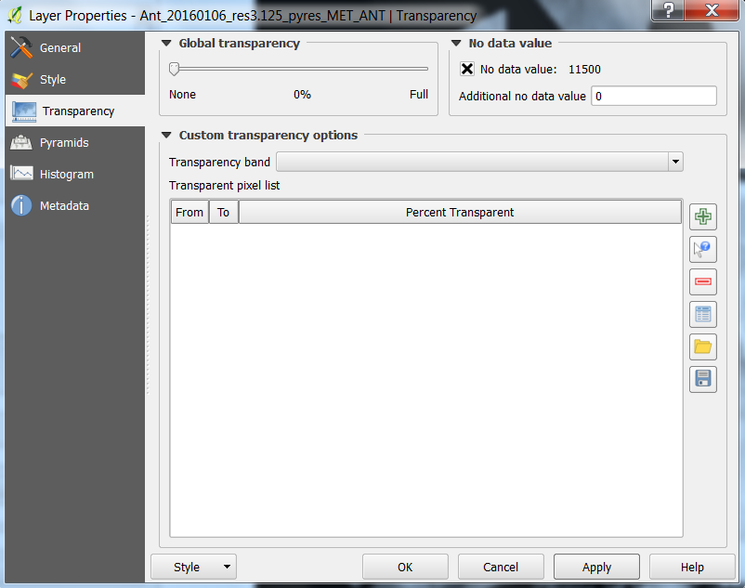

Press Apply and close window by pressing OK.

iii) Optional to select a few MODIS images. Not necessary for Exercise 1.

iii) All layers will be in the same projection and will overlay each other. AMSR2 and ASCAT have provide global coverage and the MODIS and Sentinel 1(S1) and 2 (S2) will provide regional coverage.

d) Projection is in custom Polar Stereographic ( * Generated CRS (+proj=stere +lat_0=-90 +lat_ts=-90 +lon_0=0 +k=1 +x_0=0 +y_0=0 +datum=WGS84 +units=m +no_defs, User 100000)

i) Check projection: Go to “Layers Panel” shown on left-hand side and right-click on raster or vector image to verify: Properties > General:

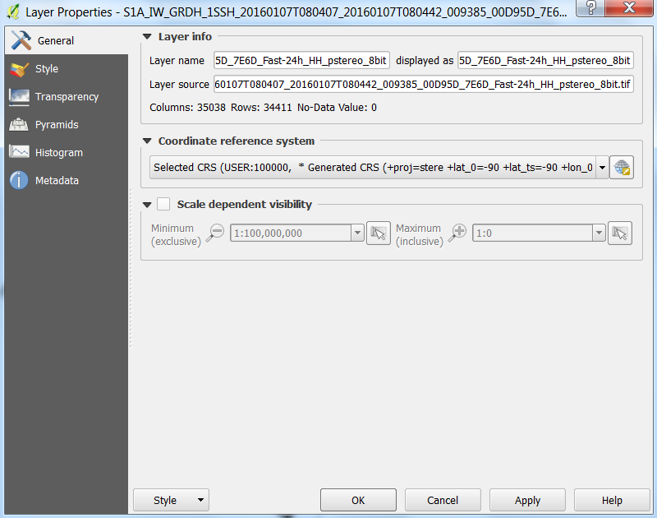

Figure 1. QGIS Layer Properties

Press Apply and close window by pressing OK.

e) Arrange images chronologically where the most recent images overlay older images and higher spatial resolution are layered on top of low resolution images. You can select any image in the Layer Properties window and drag it above or below another image. Sequence follows: Sentinel 1 or 2(1), AMSR2(2), and NIC_ASCAT(3).

f)Save file

***Part II Exercise 1: Antarctic Ice Edge creation***

Satellite images are only used to provide information on the sea ice location, type, and distribution. Operational ice charts are created in a vector format which allows you to delineate areas of different ice types and archive information regarding sea ice concentration, ice types, and any other information you would like to include when analyzing sea ice for an area (e.g. )

3) Create new shapefile layer: Layer > Create Layer > New Shapefile Layer > Polygon

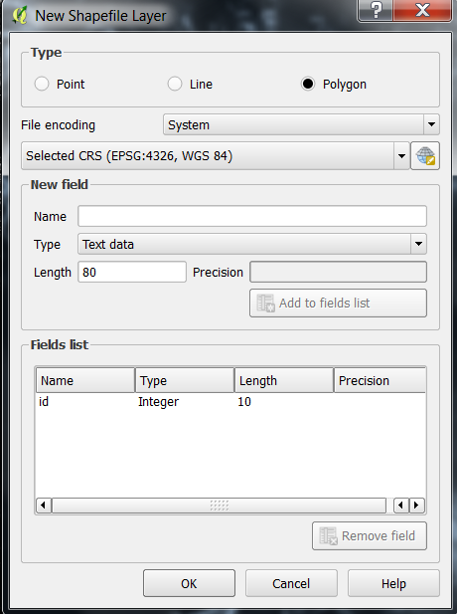

a) Change Selected CRS to Selected CRS User 100000 from drop down menu

b) Save as *Exercise1_edge*:

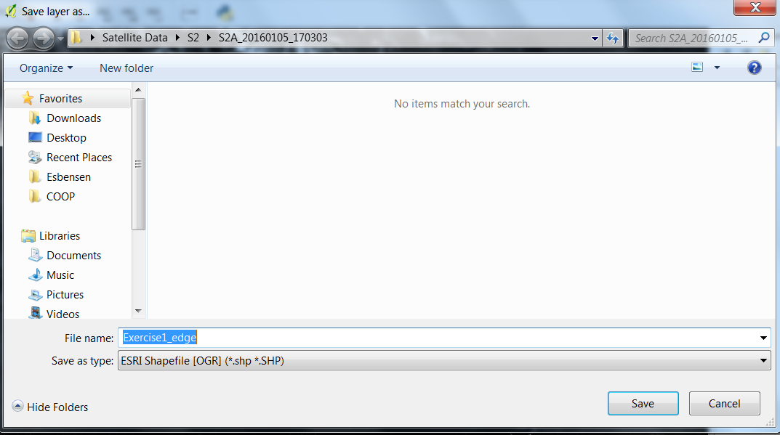

c) The vector file is located in the Layer Properties above or below the raster files. Move this file to the top of the list

d) Fill the Exercise1_edge vector file with a shape. If  *Exercise1_edge* is not in Layer Properties add it from QGIS: Layer > Add Layer > Add Vector Layer > Polygon > Browse > Exercise1_edge.shp > Open

Otherwise

Select *Exercise1_edge* and activate the Toggle Editing button: 

This allows you to edit the file by activating the plugins to modify the vector file *Exercise1_edge* using QGIS tools and plugins. Include  *Digitizing tools* Plugin if not installed. Check to see if Digitizing tools are installed by going to: Plugins > Manage and Install Plugins > Digitizing Tools (if not already selected) > Install Plugin.

Your toolbar should look like the following:

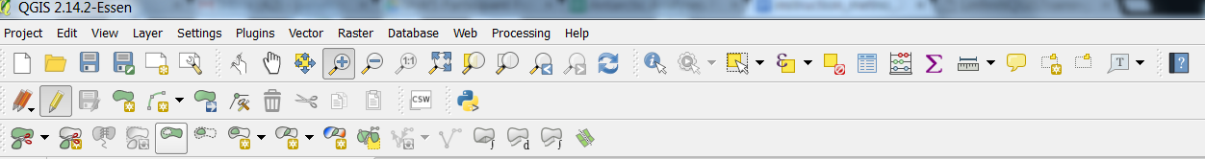

3. Select an area and create a polygon with Add Feature button: . Click an area and drag the line to make a shape within an area of the pack ice:

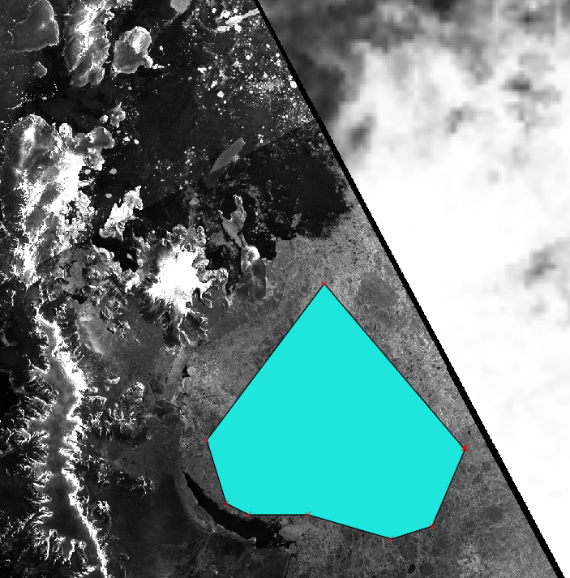

i) Attribute input window will pop-up so input the following sea ice code based on the following information:

**Sea Ice**

The initial ice chart layer provides blank coverage polygon for the ice chart. The polygons for BiFrost have *iceconc* and *icetype* attributes. See Table 1 for the ice concentration for BiFrost.

|  |  |
| --- | --- |
| *Iceconc value* | *Ice concentration* |
| **0** | Ice free (undefined) |
| **1** | Open water |
| **2** | Very open drift ice |
| **3** | Open drift ice |
| **4** | Close drift ice |
| **5** | Very close drift ice |
| **6** | Fast ice |

**Table 1: Ice concentration classes and corresponding values.**

**Creating, Saving and Printing Maps**

BiFrost:

The page layout tools for generating a map for printing can be found in the *File* menu. This gives the option to add a *New Print Composer* , open the *Composer Manager* , or select a *Print Composer* individually.

**Main Ice Chart map**

Select the map area from the BiFrost drag it into the map window. The following layers should be made visible in the main QGIS window:

Antarc_yyyymmdd_Ex1_QGIS (ice chart layer),  
Iceshelf

Pack Ice

Marginal Ice Zone

Landmask (provided)

Satellite products (provided)

Optional:

points_antarctic (longitude/latitude points),  
graticule_antarctic (longitude/latitude lines),

Select the Legend box. Edit the text for *Legend items* (hit the button at the bottom-right to bring up the list) and remove items such as longitude/latitude lines that should not be listed.

Save a new template file, then generate an output PNG graphic , before closing the print composer window. The name of the PNG graphic should be antarc_Ex1_(SIPAS or BiFrost).png.